Supporting Information
Sub-micron patterning of metal oxide surfaces via microcontact printing and microtransfer molding of amphiphilic molecules and antifouling application

Josué Cordero Guerrero¹, Gabriel Jiménez Thuel¹ and Sergio A. Paniagua*^{2,3 ORCID ID}
¹Chemistry Graduate Program, Universidad de Costa Rica, San José, Costa Rica
²Natural Sciences Department, Universidad de Costa Rica, Alajuela, Costa Rica
³National Nanotechnology Laboratory (LANOTEC), CENAT-CONARE, San José, Costa Rica.
*Address all correspondence to this author: spaniagua@cenat.ac.cr / sergio.paniagua@ucr.ac.cr
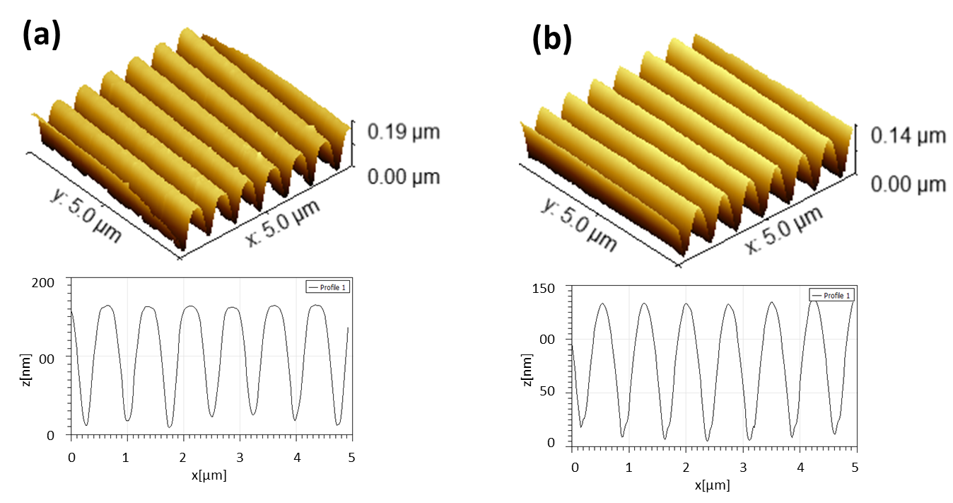
Fig. S1. AFM of DVD-R (a) and a PDMS replica (b) with their corresponding cross sections across at mid image.

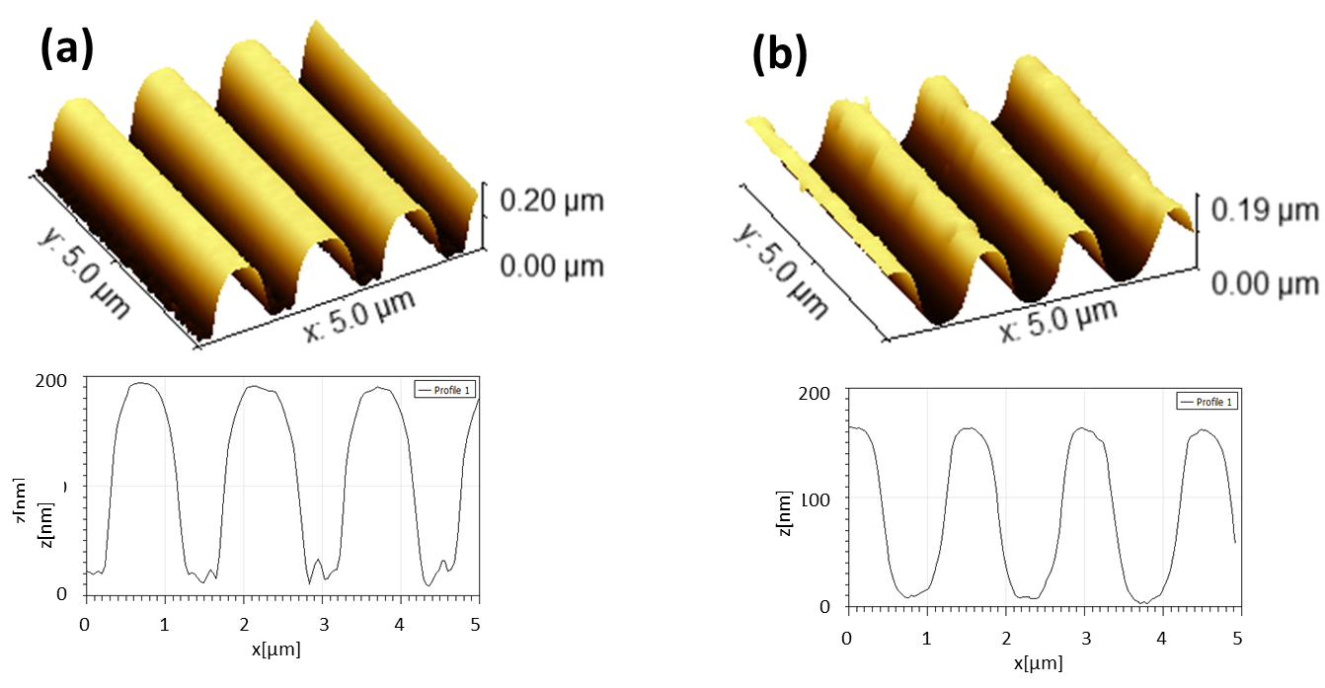
Fig. S2. AFM of CD-R (a) and a PDMS replica (b) with their corresponding cross sections at mid image.
Table S1. Summary of observations for smooth clean substrates, monolayer-coated smooth controls and patterned samples.
Sample | Film / Pattern Thickness (nm) | Crest FWHM  (nm) | Observed water contact angle (°)
Freshly cleaned mica | NA | NA | Complete wetting (<30°)
Spread coated ODPA on mica* | 1.4±0.2 | NA | 78±10
µCP (DVD-R) ODPA on mica | 6.7±0.3 | 430±80 | 43±5
Plasma cleaned Si wafer | NA | NA | Complete wetting (<30°)
Spread coated ODPA on Si wafer | NA | NA | 92±1
µCP ODPA (DVD-R) on Si water | 1.9±0.4 | 390±60 | 93±5
Electropolished Al AA6063 (EP Al) plasma cleaned | NA | NA | 32±3
Monolayer ODPA on EP Al | NA | NA | 95±5
µTM ODPA (CD-R) on EP Al | 850±80 | 150±20 | 110±1
µTM ODPA (CD-R) on EP Al/Etchant A/ML ODPA | 820±80 | 150±30 | 110±4
µTM OTES (DVD-R) on EP Al | 420±40 | 55±6 | 101±3
µTM OTES (DVD-R) on EP Al/Phosphoric acid etch | 310±50 | 46±2 | 31±6
µTM OTES (DVD-R) on EP Al/Acid etch/Plasma strip | 300±30 | 33±3 | Complete wetting (<30°)
*AFM shown in Fig. S3.

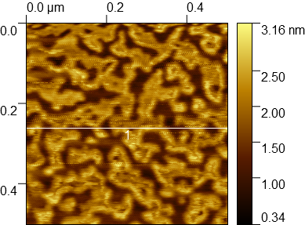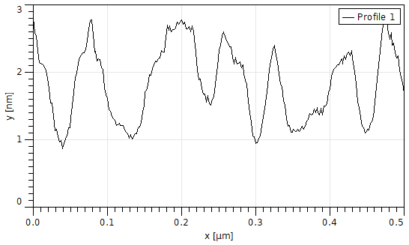
Fig. S3. AFM of spread-coated ODPA on mica (left) and cross section view of heights following white line (left).

