ANEXO 1

City of Fish

Costa Rica


List of available species

Pacific Coast

Northern Area (Guanacaste)

Feb 2011

Holacanthus passer

Angel Real / King angelfish
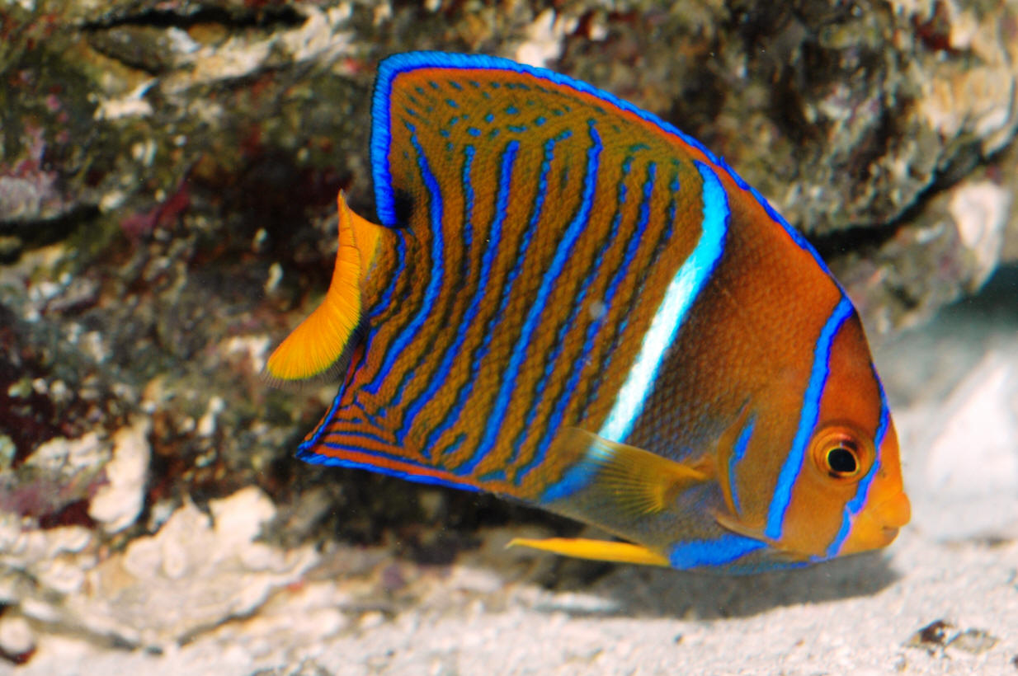

Pomacanthus zonipectus

Angel Cortéz / Cortez Angel
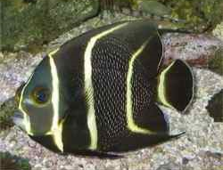

Thalassoma lucasanum

Arcoiris de Cortéz (Cabeza Azul) / Cortez Rainbow Wrasse (Blue Head)

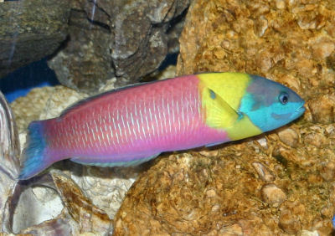

Thalassoma lucasanum

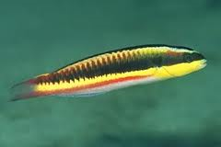
Arcoiris de Cortéz (Mexicano) / Cortez Rainbow Wrasse (Mexican)

Alphestes immaculatus
Cabrilla / Pacific Mutton Hamlet

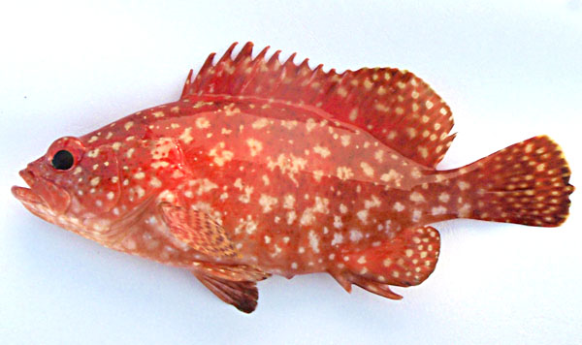

Bodianus diplotaenia

Hogfish / Mexican Hogfish

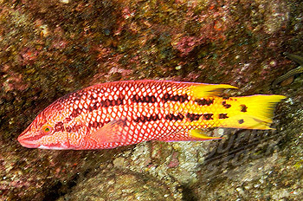
Chaetodon humeralis
Mariposa blanca / Threebanded butterflysh

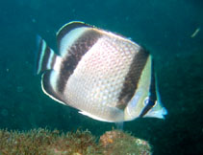

Johnrandallia nigrirostris

Mariposa amarilla / Barberfish

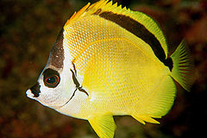

Microspathodon dorsalis

Pez Joya / Giant Damelfish

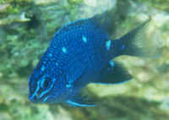

Gymnothorax meleagris

Culebra Arenera / Whitemouth Moray

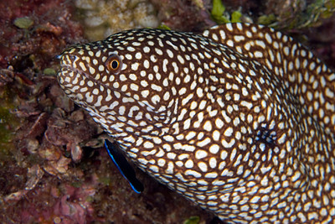

Scuticaria tigrina

Culebra Overa / Tiger Reef Eel

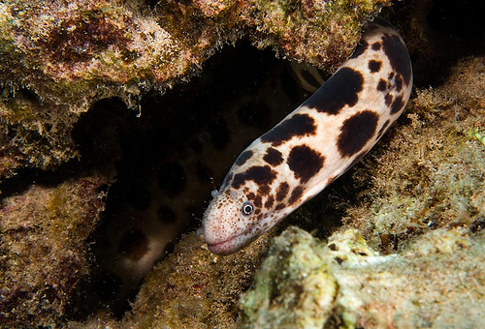

Gymnomuranea zebra

Culebra Cebra / Zebra Moray

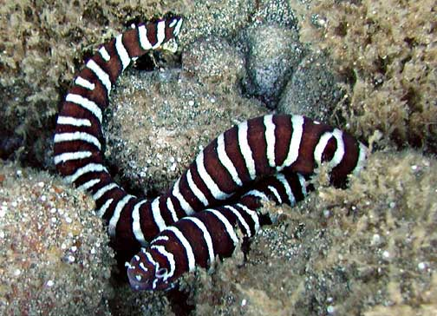

Scarus rubroviolaceus

Loro Bicolor / Bicolor Parrotfish

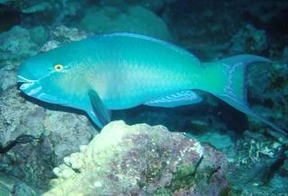

Diodon holocanthus

Spiny Puffer /

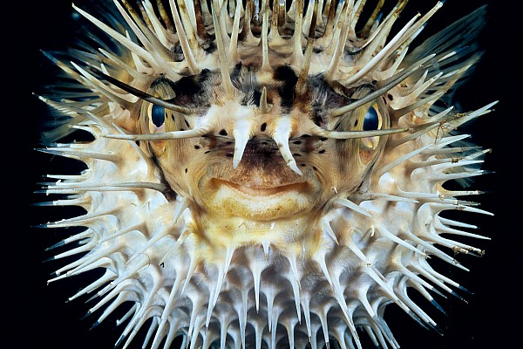

Arothron hispidus

Puffer Azul / Stripebelly Puffer (Blue)

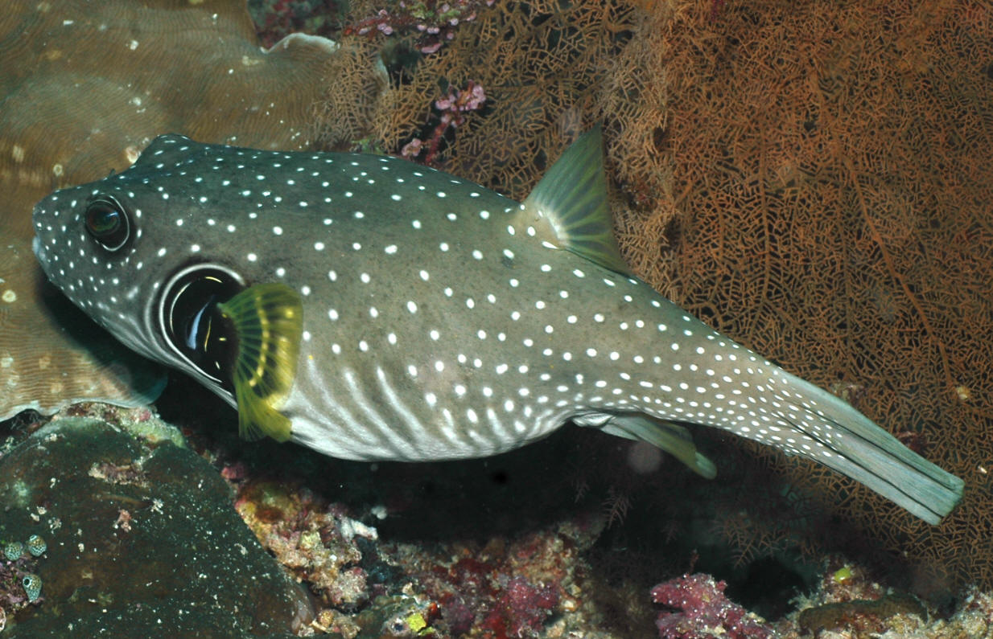

Arothron hispidus

Puffer Amarillo / Stripebelly Puffer (Yellow)

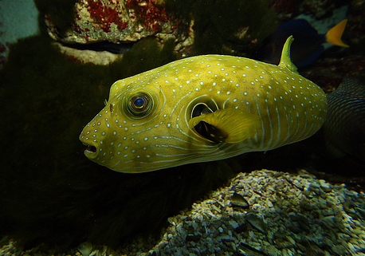

Apogon atradorsatus

Cardenal / Black Cardinalfish

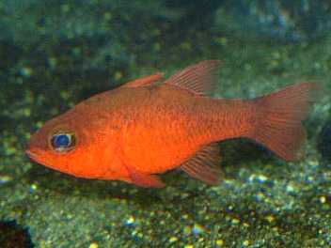

Antennarius commersoni

Caminante / Commerson´s Frogfish

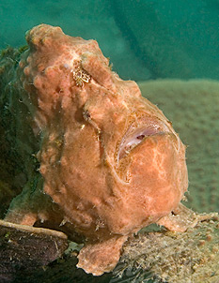

Elacatinus puncticulatus

Gobies Cabeza Roja / Redhead Goby

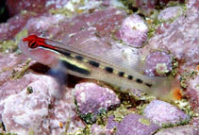

Pristigenys serrula

Popeye / Popeye Catalufa

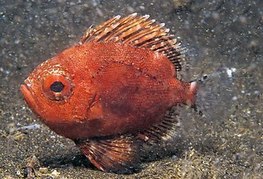

Paranthias colonus

Rubi Rojo / Pacific Creolfish (Red)

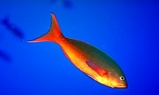

Paranthias colonus

Rubi Amarillo / Pacific Creolfish (Yellow)

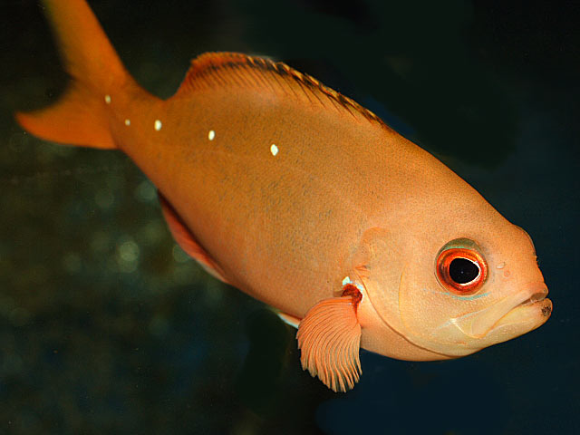

Novaculichthys taeniourus

Zorgazo / Rockmover Wrasse

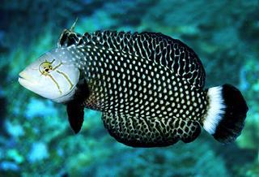

Hypancistrus cebra

Cebra / Zebra

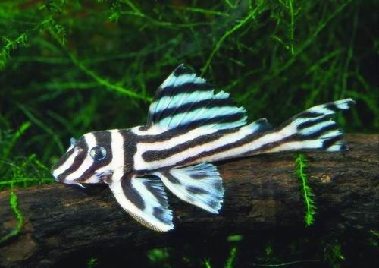

Ophioblennius steindachneri

Pez perro / Panamic Fanged Blenny

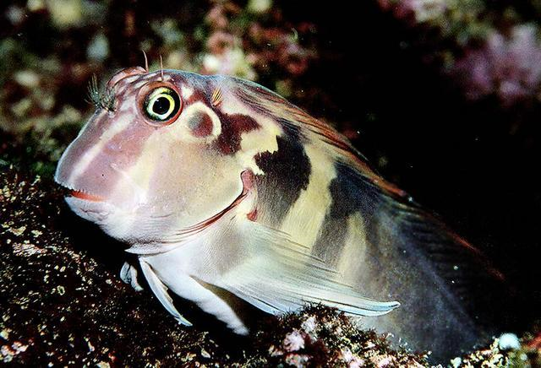

Canthigaster punctatissima

Pez globito / Spotted Sharpnose Puffer

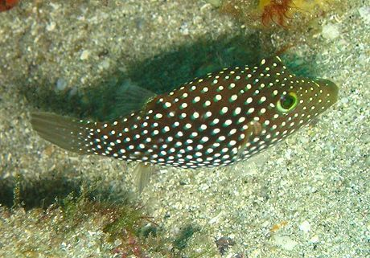

Halichoeres salmofasciatus

Pez Doncella / Red-Stripped Wrasse

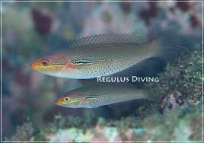

Halichoeres salmofasciatus

Pez Doncella / Red-Stripped Wrasse (Mexican)
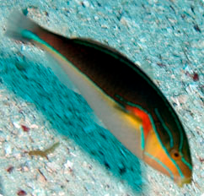

Acanthurus nigricans

Cirujano Cariblanco / Goldrim Surgeonfish

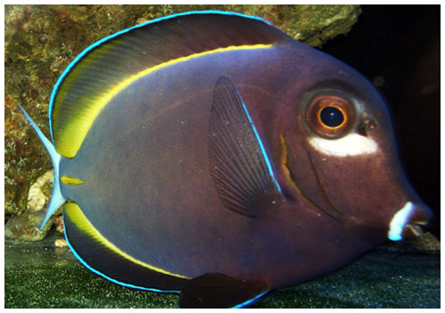

Acanthurus triosteguss

Cirujano Reo / Convict Surgeonfish

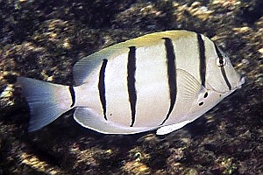

Acanthurus xanthopterus

Cirujano Aleta Amarilla / Yellowfin Surgeonfish

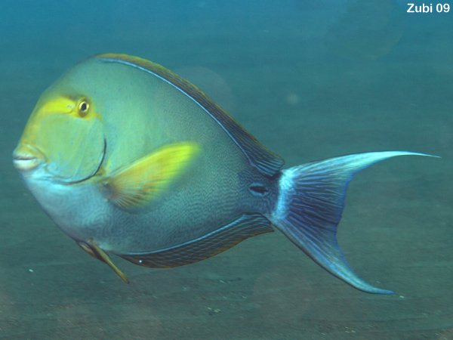

Ctenochaetus marginatus

Cirujano Estriado / Blue-Spotted Surgeonfish

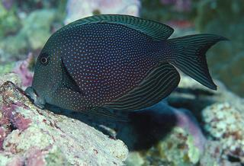

Prionurus laticlavius

Cochinito Barbero / Razor Surgeonfish

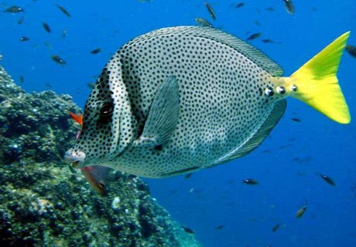

Zanclus cornutus

Idolo Moro / Moorish Idol

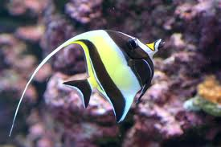

Stegastes variabilis

Damsel

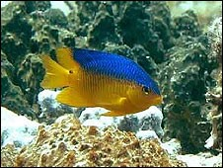

Stegastes arcifrons

Mariposa Negra / Yellowtail damselfish

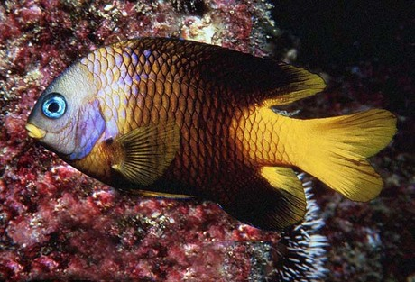

Carcharhinus albimarginatus

Tiburón Puntas Blancas / Silvertip Shark

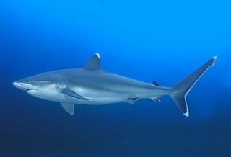

Taeniura meyeni

Raya Moteada / Marbled Ray

